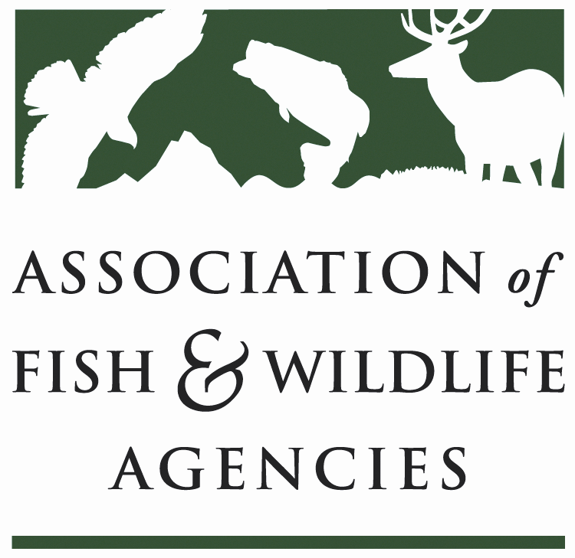

WILDLIFE RESOURCES POLICY COMMITTEE
Chair: Jim Douglas, (Nebraska)
Vice-Chair: Chuck Sykes (Alabama)

Wednesday September 12, 2018
10:00 AM – 12:00 PM

Association of Fish and Wildlife Agencies Annual Meeting
Room: Florida Salon V
Tampa Marriott Waterside Hotel | Tampa, FL

Committee Charge
To discuss and develop recommendations on Association positions related to federal laws, regulations and policies concerning habitat conservation, wildlife resources and related funding for such programs as well as wildlife management practices including those concerned with problem or nuisance wildlife, and emerging issues (e.g., commercial trade). The committee also stays abreast of threatened and endangered species wildlife issues, state legislation pertaining to wildlife management and wildlife diversity funding initiatives.

Agenda

10:00 AM Welcome, Introductions, Review Agenda, Approve Meeting Notes-Jim Douglas, NGPC

10:10 AM Wildlife Services Report-Martin Mendoza, USDA/APHIS

10:30 AM Multiagency MOU on Aircraft-Wildlife Strikes- Martin Mendoza, USDA/APHIS

10:35 AM Human/Wildlife Conflicts Working Group Report-Brian Wakeling, NDOW

10:55 AM Landscape Conservation Working Group-Jim Douglas, NGPC
- Update to White Paper on Landscape Conservation
- Resolution on Landscape Conservation

11:15 AM Update on Department of Interior Reorganization-Jim Kurth, FWS

11:25 AM Update on Bats & Proposed Working Group-Mylea Bayless, BCI

11:40 AM Renewable Fuel Standard Relationship to Wildlife and Landuse-Bill Moritz, WMI

11:45 AM Update on Regional Monarch Conservation Strategy-Ed Boggess, FWS

11:50 AM Committee Work Plan-Jim Douglas, NGPC

12:00 PM Adjourn

