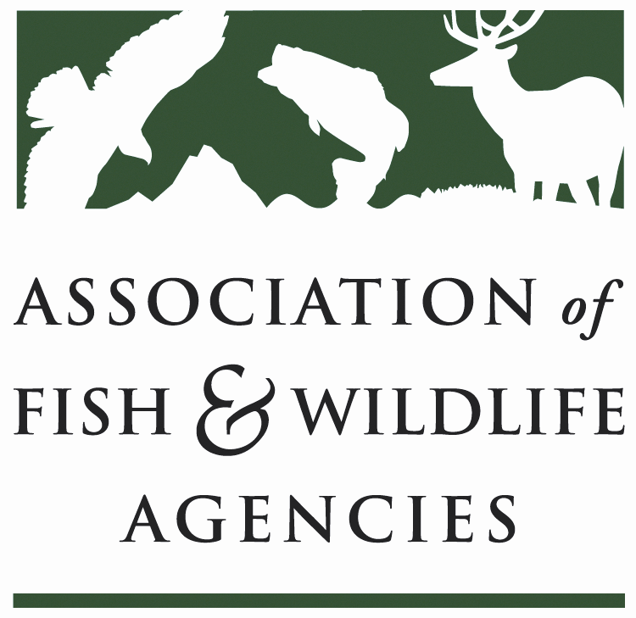

Wildlife diversity conservation & funding Committee
Chair: Sara Parker Pauley (Missouri Dept. of Conservation)
Vice Chair: David Whitehurst (Virginia Dept. Game & Inland Fisheries)

Tuesday September 11, 2018
8:00 am to 12:00 pm

Association of Fish and Wildlife Agencies Annual Meeting
Meeting Room-Florida Salon V
Marriott Waterside Hotel & Marina | Tampa, FL

Committee Charge Advocate for long-term dedicated funding and annual appropriations for the conservation of species of greatest conservation need, nature-based recreation and conservation education and support development, implementation and revision of State Wildlife Action Plans.

Agenda
08:00AM Call to Order/Review Agenda/Introductions-Sara Parker Pauley, MDOC

08:15AM Approval of Committee Report from the March 2018 Meeting-Sara Parker Pauley, MDOC

08:30AM Recovering America’s Wildlife Act/Alliance for America’s Fish & Wildlife
- House & Senate Legislation & Advocacy Campaign-Sean Saville, AFWA
- Business and Partner Relationships-Carter Smith, TPWD
- Report from EOD/WDCF Joint Working Group-Jen Newmark, NDOW

09:15AM Blue Ribbon Panel Agency Relevancy Working Group Report & Proposed Resolution on Fish and Wildlife Relevancy-Steve Williams, WMI; Sara Parker Pauley, MDOC

10:00AM -BREAK-

10:15AM Results from the America’s Wildlife Values Survey-Mike Manfredo, CSU

10:30AM State & Tribal Wildlife Grants
- FY19 Funding-Mark Humpert, AFWA
- Competitive State Wildlife Grants Working Group Recommendation-Rex Sallabanks, IDGFD
- State Wildlife Grants Effectiveness Measures Framework-Mark Humpert, AFWA

11:00AM Wildlife & Sport Fish Restoration Program Update-Christy Vigfusson, USFWS
11:15AM State Wildlife Action Plans-Mark Humpert, AFWA
- Implementation Best Practices Working Group
- Federal/State MOU

11:30AM Update on the Mid-America Monarch Strategy-Ed Boggess, FWS

11:40AM Review 2018 Committee Work Plan-David Whitehurst, VDGIF

12:00PM Adjourn

