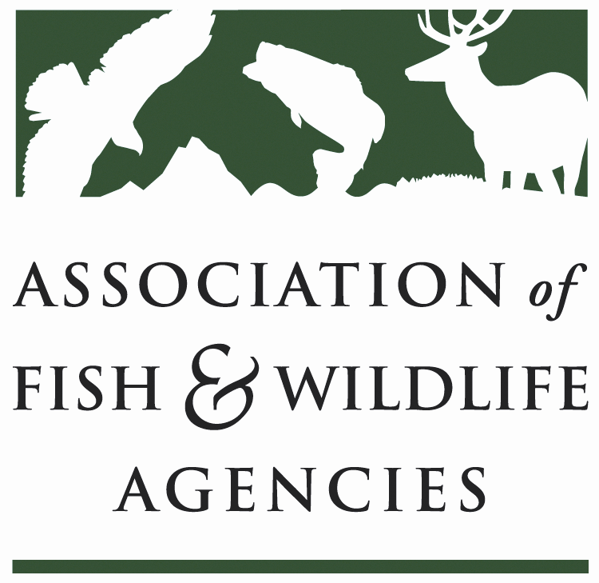

Ocean Resources Policy Committee
Chair: Curt Melcher (OR)
Vice-Chair: Robert Boyles (SC)

Friday, March 30, 2018
8:00 am – 10:00 am
Salon F
Hilton the Main

83rd North American and Wildlife Resources Conference
Norfolk, VA

8:00 am Call to Order/Introductions/Review Agenda – Curt Melcher, OR
- Action: Approval of Draft Meeting Agenda/September 2017 minutes

8:10 Review NCN Submission and Process – Devin DeMario, AFWA
- Examine setting items for a broad NCN or keep NFHP NCN
- All current NCNs are going to advance to next stage
- Funding for FY 18 cycle just released
  - NHFP Project Tracking Database was mentioned
- Interest in development of broad joint NCN to cover more topics?
8:20 National Fish Habitat Partnership Update – Tom Champeau, FL
Ryan Roberts, AFWA
- Board membership - 22
- States
- Federal agencies
- NGO Community
- Professional Association
- Board Update - 10th anniversary
- 20 partnerships
  - Different focus areas – Species, Area and Habitat Type
  - No new FHPs in cue
- Board will review partnerships – Learn what work is being done
- Consistency with Fish Habitat Action Plan is a key Board role
- Discussed staff changes – Alex joined from NOAA
- Partnership networking key
  - 700 projects with 3:1 fund ratio
  - Close working relationships with local entities
- Provided examples
  - Shelikof Creek AK – SEAKFHP
  - PA statewide work – TU $4.5 million to $500K
- Legislation
  - Came close last year
    - Senate there is movement
    - House movement is occurring
  - Board will be larger with marine, private and tribal additions
  - Provides funds to federal agencies for support
  - Secretary selects projects from funds
  - MOU has expired and awaiting
- Beyond the Pond
- 501c3 in place
- All FHPs chapters
- Bylaws and Board in place with overlap
- Online donation page
- Partners
  - BassPro helped with 10 year anniversary video
  - 3% of purchases from Repyourwater to Driftless FHP with more coming - $50K for conservation organizations last year
    - We will be one of 12 entities to get conservation – 10% of sales
- Improved habitat = more opportunities
  - R3 support

8:30 National Fish Habitat Assessment Update – Gary Whelan, MI
- PPT given
8:45 NOAA/NMFS Updates - Heidi Lovett, NOAA-NMFS
Chris Wright, NOAA-NMFS
- Leadership changes
- Gallaudet – Assistant Sec for wet side
- Chris Oliver – Assistant Administrator – NP Council formerly
- Neil Jacobs – Assistant Sec for Environmental Observation and Prediction – Dry side
- Barry Meyers – NOAA Administrator – Awaiting a hearing
- Omnibus – NMFS - $883 million and $30 million increase
- Mostly level funding
- Full blue book on their website
- Key Priorities - Weather, NOAA fleet, MSA and ESA responsibilities, Coastal navigation
- FY19 – Reduction from FY18 – NOAA 17% at $837 million with a decrease
- Grants to states – up to $200 million and at a stable percentage
- Grants
- SK Program – 517 pre-proposals and 155 full
- BREP – 92 pre and 45 full
- NFWF – Coming in the spring
- Fishery disaster assistance – a range of requests across the country
- EBFM
- Policy released 2017
- Roadmap released 2017
- Drafts available now
- Final in Dec.
- Stock status will be released soon and positive indications
- Sustainable Fisheries
- Significant Congressional activity
- Recreational Fisheries Summit ongoing right now with outcomes in Sept.
- MRIP – New survey which replaces phone survey
- Finalized method peer reviewed last week
- Recalibrated survey results by July 1 for shore and boat estimates
- Implementation Plans – ID regional data needs
- Habitat Grants
- Coastal Resiliency Grant – 186 pre-proposals - $100 million
- Chesapeake Bay Office Fisheries Science Grants – Summer flounder and black sea bass survivability and production – inshore and offshore habitat and estuary habitat available – Proposals due 4/26/2018
- Depending on appropriations
- Habitat Conservation
- Fish Passage Program review including hydropower program – Summer due date for reports
- NFHP Regional Assessments
- NE Habitat Climate Vulnerability Assessment
  - Species predictions with conditions – NE done and NW nearly done, others behind
  - Habitat analysis moving forward in NE – Help to prioritize locations
- Habitat Focus Area Effectiveness Reviews – Habitat blueprint
  - Examining what has worked and not
8:55 NMFS Presentation – Heidi Lovett, NOAA-NMFS
- NOAA Fisheries Priorities and Annual Guidance for 2018
- Law Enforcement Priorities, FY 2018-2022
- NOAA Goals and priorities
- Max fishing opportunities for sustainable fisheries
  - Leverage opportunities
  - Bycatch strategies
  - Reduce regulatory constraints
  - Aquaculture production
- Recover and conserve protected species
  - Improve recovery plan effectiveness
  - Species in spotlight is continuing with 5 year action plans
  - Advance science for west coast species and sturgeon
- Improved agency efficiency
  - Risk management with funds and priority investments in assets an tech
  - Outdated regulation removal
  - Link science and management enterprises to improve focus on real-time mgt issues
- Enforcement priorities – 5 year plan
- Enforces and promotes compliance with marine resource laws and implement regulations under NOAA
  - Issue with repeat offenders licenses in federal waters
  - Deter, detect and investigate – Illegal harvest, sanctuaries enforcement.

9:15 Office of National Marine Sanctuaries: An update– Grace Bottitta, ONMS
- Two items – Five Year Strategy
  - Got input from a range of groups from ASA to AFWA with focuses on:
    - Responsible human uses certification for fishing to boating
    - Reduce direct impacts
    - Mooring buoys in sensitive areas
    - Sustainable fishing activities in sanctuaries
  - New sanctuary in MD – Potomac River Bay
    - Ghost fleet protection focus - NOAA
    - Non-regulatory approach generally – MD overseeing fisheries
9:25 Marine Monument Update – Heather Sagar, NOAA-NMFS
- Administration review of NMM’s
- April 28 – Executive Order – America First Strategy
- Review all marine monuments over last 10 years – 6 expansions, 1 monument expansion, 3 new monuments
- State and tribal consultation, opportunity costs for extraction forgone, management costs
- Worked with a range of entities and comment period
- Report was due in October and not out yet
  - Department has report
9:35 Marine Legislation Update – Devin DeMario, AFWA/All
- Summary will be distributed
- Budgets – FY18 and FY19
- Many zeroes
- AFWA will be working on developing appropriations requests to congress
- Modernizing America’s Fisheries Act – Data management and increase options for stock mgt
- Vessel Incidental Discharge Act – Reduce state authority on ballast water and move all to USCG
- HELP Act – Includes NFHP legislation
- Infrastructure and WRRDA/WIIN
- Mentioned including recreation as designated use in USACOE navigation structure
- Include natural marine processes in disaster relief and infrastructure
- MMPA – Issues with pinnipeds preying on endagered salmon/migratory fish in Columbia River – allows for more effective management of sea lions
- Bird – Fish Conflict Working Group established
- Recovering America’s Wildlife Act – Moving forward and recent fly-in
- States best place to make fisheries decisions – NJ case example of NOAA issue – Menhaden storm coming
9:45 Discussion on Mariculture - All
- NOAA Fisheries Marine Aquaculture Strategic Plan
- States challenges, needs, and current operations
- SC has supported aquaculture but has issues with wild stock management
  - Oyster culture – Manage risks to wild stock resources
  - SC got legislative inquires on oyster effects and told about adjacent states allowing anything
    - Requested polling the states on positions
  - FL similar issue – Research and development – Gulf Council interactions
- Congressionals pushing AFWA for a position
- WA has ATS net pen ban and phase out in 10 years
- MI has indicated opposition to Great Lakes net pen operations in our state and indicated that there are joint proposals for wind farm and net pens.
  - Send white paper to Robert Boyles

9:55 Meeting wrap-up and adjourn – Curt Melcher, OR

10:00 – 11:00AM Marine Protected Area Panel Discussion

Committee Charge:
Discuss, develop, and recommend Association positions related to:
  - Federal laws, regulations, and policies concerning marine ecosystems, habitats, fisheries and other resources, and related funding for such programs.
  - Marine fisheries management programs, practices or considerations (e.g., Marine Recreational Information Program, catch shares) and emerging issues (e.g., climate change, coastal energy, marine aquaculture and marine spatial planning).

- Marine Protected Areas
  - Joint state-federal efforts noted by most panelists
    - $25 million NOAA budget oversees
  - Umbrella term that includes any geographic area to provide a level of protection than other areas
    - Making sure the public understands the value within the ability of the area to allow it
    - Broad authority given to superintendents
  - Have cross deputized state law enforcement, work on science, and co-management
  - High diversity of systems
  - USFWS – Similar to terrestrial refuges and under that program
    - Generally close relationships with state agencies
  - Key aspect
    - Relationship to people – 29 National estuarine reserves – All operate similarly
      - Data collection similar at all locations
    - MPA do not mean shutting down fisheries and is a tool
      - To meet mandates under Mag-Stevens
      - Could be used for gear restrictions to protect things like deep corals
      - Open forums used in this area
        - Council meeting partners are critical
    - Preserve unimpaired places for the future
      - Public engagement are equal to preservation
    - Advisory Councils which are broad range of local interests
      - Input and guidance to superintendents
    - Part of National Wildlife Refuge system – Organic Act is the special place for wildlife
  - Pacific Coast – Tension between Sanctuary, Council and NMFS on who is in charge of fishery – Has it changed
    - Advisory Process guided process early on
    - NMFS and Sanctuary Service – Had a summit to resolve issues
      - Continue internal discussions to improve process
    - Navigation issues with sanctuaries with shutdowns and conflict with public trust
      - Little leeway with Executive Office directions
      - Monuments would require gear stowing during shutdowns
      - Areas to be avoided at size and areas have some gear stowage requirements
      - Reserves is it not an issue
      - Parks with ICWs – free transit. Free and open navigation with authority on boating to prevent issues
  - FL Atlantic Coast – Community lead activity to make sanctuary and unclear when to engage state agency
    - Slides will be set to FL and process has changed
  - Comprehensive Management Plan – USFWS and NOAA – NEPA document and a lot of input
    - Executive Order provides large items such as no mining….
    - How to collect science or exploring the system are issues in plan

