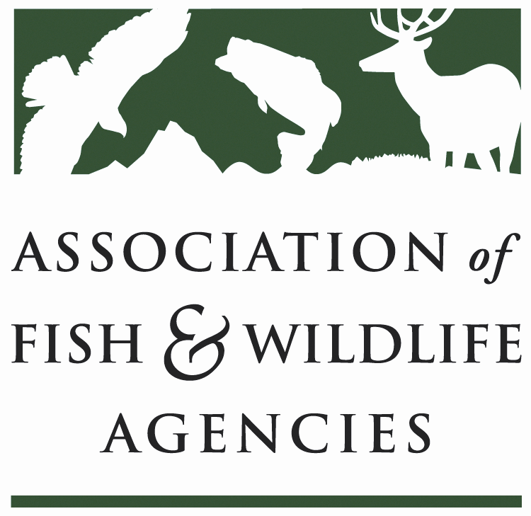
Science & Research Committee
Chair: Russ Mason (MI)
Vice-Chair: Karen Waldrop (KY)

Monday, September 10, 2018
10:00 AM – 12:00 Noon
108th Annual Meeting of the Association of Fish and Wildlife Agencies
Tampa, Florida

Agenda

- Call to Order/Review Agenda/Introductions (5 minutes)
Russ Mason (MI)

- Committee Business (5 minutes)
  - Proposed Resolution in Support of Joint TWS/AFS Meeting in 2019

- Programmatic Updates (80 minutes)
  - National Cooperators Coalition update John Kennedy (WY)
  - Strategic, Collaborative Science to Inform Conservation at USFWS Benjamin Tuggle (USFWS) and John Organ (USGS)
  - Landscape Conservation Update Elsa Haubold (USFWS)
  - Wildlife Science at the National Academies Robin Schoen (NAS)
  - Human Dimensions Subcommittee Update Ann Forstchen (FL)
  - Monarch Butterfly Conservation Science Plan Ed Boggess and Claire Beck (MAFWA)

- Committee Discussion: Species Distribution Models As Tools for Conservation and Management (30 minutes)
  - Introduction and Case Studies Tom Edwards (UT Coop Unit), convener and discussion leader
  - Scope and Focus of Possible TWS Study on Species Modeling (Keith Norris, TWS)

Objectives and Desired Outcomes for Committee Discussion:
  - Identification of appropriate applications of species distribution models to problems in fish and wildlife management.
  - Discussion regarding scope of proposed TWS study of species modeling approaches.

- Adjourn

