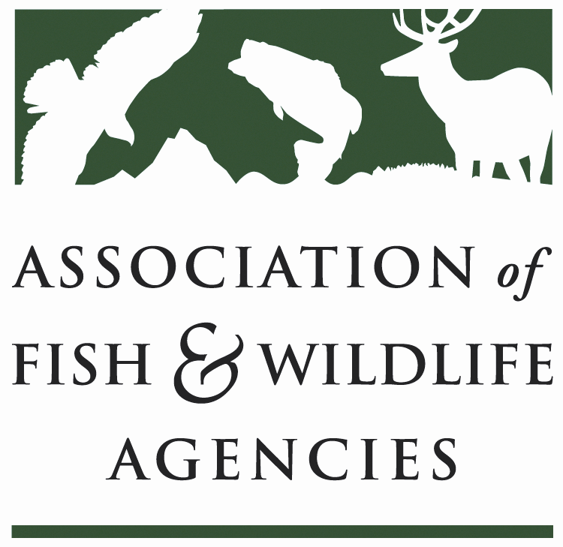

Human Wildlife conflict Working Group
Chair: Brian Wakeling (Nevada)
Vice-Chair:

Tuesday, September 11, 2018
10:00 AM – 12:00 PM

Association of Fish and Wildlife Agencies 108th Annual Meeting
Tampa Marriott Waterside Hotel and Marina
Tampa, Florida

Agenda

- Call to Order/Review Agenda (Chairman Wakeling)

- Introductions

- Approval of Minutes for the meeting of the HWCWG from the North American Wildlife and Natural Resources Conference

- Report on progress toward the development of peer reviewed publications on human-wildlife conflicts with; (Bryant White)
- Black Bears

- Deer in Populated Areas

- Urban Coyotes

- Discussion on - - -
  - Other topics of interest

- State/Federal/Tribal/Provincial Roundtable
One representative per agency highlights a couple of human wildlife conflict issues

- Wrap-up Discussion and Assignments for Next Meeting

- Adjourn

