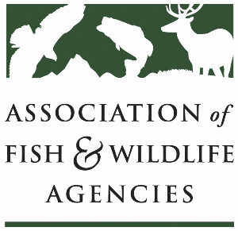

**Subcommittee on water**

Chair: Julie Carter (AZ)

Vice-Chair: Bob Caccese (PA)

Monday, September 22

10:00 am – 12:00 pm

115th Annual Meeting of the Association of Fish and Wildlife Agencies

Tucson, Arizona

**Agenda**

10:00 am Call to Order/Review Agenda/Approval of Minutes – *Julie Carter, AZ*

10:05 am Introductions – *All*

10:10 am Virtual Pre-Meeting Recap – *Julie Carter (AZ)*

10:15 am Government Affairs Update – *Bob Caccese (for AFWA)*

* Federal Budget, Permitting Reform, CWA 401 Listening Sessions

10:30 am SOW Response to Federal Water Policy *– All*

* Gauging interest and availability in developing positions and making recommendations to FWRPC and AFWA on proposed legislation/administrative actions

10:45 am Instream Flow Council Update – *Christopher Estes, AFWA Life Member*

* National Center for Ecologically Sustainable Water Conservation and Management

10:55 am Roundtable on State Water Quantity and Quality Issues *– All*

11:15 am PFAS Discussion *– All*

11:30 am SOW Work Plan Discussion – *Julie Carter, AZ*

11:45 am Federal Partner Updates *– TBD*

11:55 am Wrap Up and Adjourn – *Julie Carter (AZ)*

* Action items for FWRPC