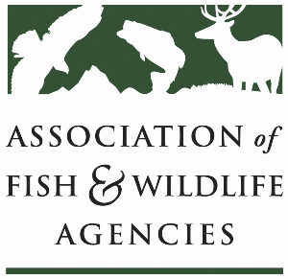

**Ocean resources policy committee**

Chair: Nate Pamplin (WA)

Vice-Chair: Dave Golden (NJ)

Monday September 22

1:15 pm – 3:15 pm

115th Annual Meeting of the Association of Fish and Wildlife Agencies

Tucson, AZ

**Agenda**

1:15 pm Call to Order/Review Agenda/Approval of Minutes (Virtual Meeting 2025 and Annual Meeting 2024) – *Nate Pamplin, WA*

1:20 pm Introductions - *All*

1:25 pm Government Affairs Update – *Bob Caccese for AFWA*

* Appointments
* FY26 Federal Budget
* Sport Fish Restoration and Boating Trust Fund Reauthorization
* MMPA Reform Discussion Draft
* Other Marine Legislation
* Update from Bird & Fish Related Conflict Working Group

1:45 pm Federal Partner Updates – *TBD*

2:05 pm National Fish Habitat Partnership Update – *Ryan Roberts, AFWA*

* National Fish Habitat Assessment
* New Draft Fish Habitat Action Plan
* 20th Anniversary

2:25 pm State Roundtable Discussion– *All*

3:00 pm Wrap up and Adjourn – *Nate Pamplin, WA*