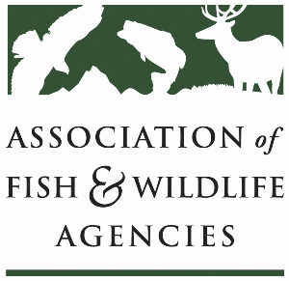

**Fisheries and WATER rESOURCES pOLICY COMMITTEE**

Chair: Jim Fredericks (ID)

Vice-Chair: Craig Bonds (TX)

Wednesday, September 24

9:00 am – 12:00 pm

115th Annual Meeting of the Association of Fish and Wildlife Agencies

Tucson, AZ

**Agenda**

9:00 am Call to Order/Review Agenda/Approval of Minutes – *Jim Fredericks, ID*

9:05 am Introductions - *All*

9:10 am Subcommittee and Working Group Reports

* Subcommittee on Water – *Julie Carter, AZ*
* Drug Approval Working Group – *Alan Johnson, IA*
* Fish & Wildlife Coordination Act Working Group – *Jen Sheehan, AR*
* Aquatic Animal Health & Aquaculture Working Group – *Bob Caccese for AFWA*
* Bird and Fish Related Conflict Working Group – *Bob Caccese for AFWA*

9:40 am National Fish Habitat Partnership Update – *Ryan Roberts, AFWA*

* 20th Anniversary
* National Fish Habitat Assessment Status
* New Draft Action Plan

9:55 am Government Affairs Update – *Ali Schwaab, AFWA*

* FY26 Federal Budget Outlook
* Administrative Updates
  + Executive Orders
  + Grants check-in
* Legislative Updates
  + Sportfish Restoration and Boating Trust Fund Reauthorization
  + Cormorant Relief Act of 2025
  + Others

10:10 am Rotenone Re-Registration – *Julie Carter, AZ*

10:25 am Break

10:40 am Gathering Information on Forward Facing Sonar Use via Creel Surveys– *All*

* Texas Parks & Wildlife Division Experience
* Discussion on sharing/standardizing forward facing sonar language for state creel surveys

11:00 am American Fisheries Society Update *– Jeff Kopaska, AFS*

* Names of Fishes Committee Update
* Responsive Management Fisheries Professionals Salary Survey

11:15 am Federal Partner Updates *– Federal Partners in Attendance TBD*

11:45 am Progress toward Establishing a National Center for Ecologically Sustainable Water Conservation & Management – *Christopher Estes, AFWA Life Member*

11:55 am Wrap-up Discussion and Adjourn – *Jim Fredericks (ID)/All*