**2024-2025 Project WILD Outstanding** **Coordinator Award Nomination**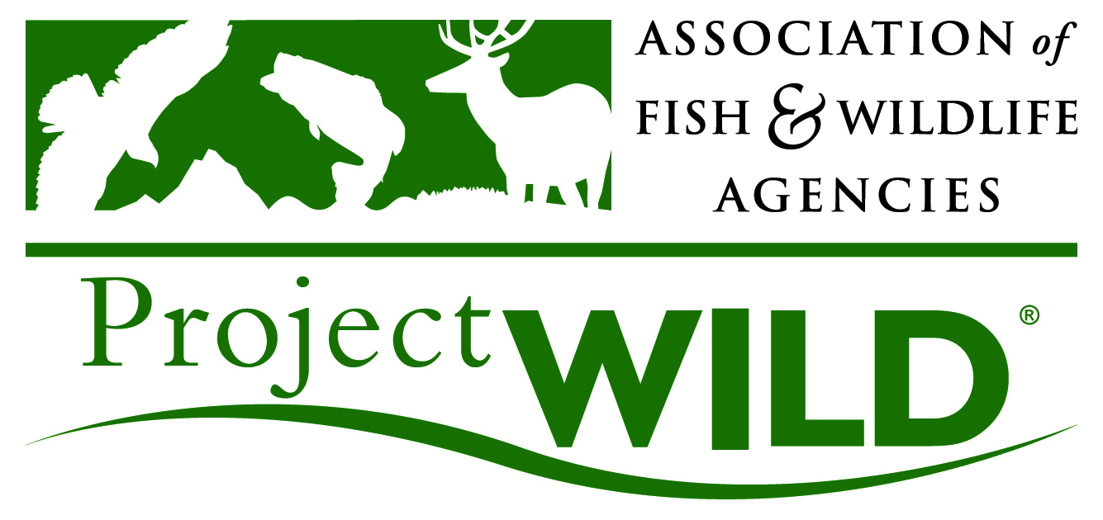

The Association of Fish & Wildlife Agencies will be presenting this award to one Project WILD Coordinator on May 22, 2025, during the 2025 Project WILD Annual Meeting.  **Nominations are due by Friday April 4, 2025.**

1. **First name of the Project WILD Coordinator** you are nominating:
2. **Last name of the Project WILD Coordinator** you are nominating:
3. **State of the Project WILD Coordinator** you are nominating:
4. Nominating party name:

1. Nominating party state:
2. Nominating party email:
3. Nominating party title:
4. Please explain why you are nominating this person (*500 words or less*).
5. Please describe the nominee's accomplishments in the area of leadership.
6. Please describe the nominee's accomplishments in the area of initiative.
7. Please describe the nominee's accomplishments in the area of innovation.
8. Please describe the nominee's accomplishments in the area of longevity.
9. Please attach a picture of the person.

**Please email this completed nomination form to projectwild@fishwildlife.org with "Outstanding Coordinator nomination" as the subject line. Thank you!**