**2024-2025 Project WILD Facilitator of the Year Award Nomination**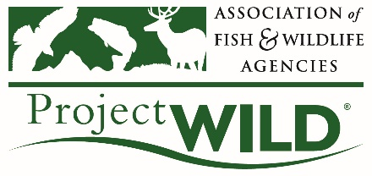

The Association of Fish & Wildlife Agencies will be presenting this award to Project WILD Facilitators on May 22, 2025, during the 2025 Project WILD Annual Meeting.  **Nominations are due by Friday April 4, 2025.**

1. **First name of the Project WILD Facilitator** you are nominating:
2. **Last name of the Project WILD Facilitator** you are nominating:
3. **State of the Project WILD Facilitator** you are nominating:
4. Nominating party name:
5. Nominating party email:
6. Nominating party title:
7. Please explain why you are nominating this person. List things they have accomplished and specific ways they have strengthened the Project WILD program. (*500 words or less*)
8. Please attach a picture of the person.
9. Please write the address to mail the certificate if you are not attending the Project WILD Annual Meeting in Maine

**Please email this completed nomination form to projectwild@fishwildlife.org with "Facilitator of the Year nomination" as the subject line. Thank you!**