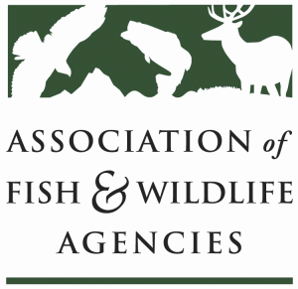

Invasive species Committee
Chair: Bill Hyatt (CT)
Vice-Chair: Kim Bogenschutz (IA)

Wednesday, March 8, 2017
1:00 pm to 5:00 pm

North American Wildlife and Natural Resources Conference
Room: Meeting Room #11 / Davenport Grand Hotel
Spokane, WA

Agenda
1:00 pm Call to Order, Welcome and Introductions, Review Agenda
Bill Hyatt, CT DEP

1:15 Update: 2018 Multistate Grant NCN Submission
Pat Conzemius, Wildlife Forever/Bill Hyatt, CT DEP

1:20 ACTION ITEMS
Request to Approve Model State Regulations for WID
Background from Priya Nanjappa, AFWA
Request to Support Federal-State Task Team Recommendations
Background from Bill Hyatt, CT DEP

1:40 NISC and ISAC Updates and Activities
Stas Burgiel, NISC/Bill Hyatt, CT DEP

1:50 Update: AFWA Feral Cat Working Group
Colin Gillin, ODFW

2:00 Discussion
MOU among PIJAC-FWS-AFWA: Updating and Revising
Bill Hyatt, CT DEP/Kim Bogenschutz IA DNR

2:20 Partner updates
USFWS (David Hoskins/Dave Miko)
ANS Task Force (Kim Bogenschutz, IA DNR)
Wildlife Forever (Doug Grann/Pat Conzemius)

Agenda (cont’d)

3:00 BREAK

3:10 Genetic and Genomic Innovations Mini-Session
eDNA detection efforts
Cindy Kolar, USGS
Mike Schwartz, USFS National Genomic Center
Genomic and gene drive efforts
Overview (Larry Clark, USDA APHIS-Vet Services)
Dorothy Zolandz, National Academy of Sciences
Heath Packard, Island Conservation
Panel Discussion:
What challenges are you facing that might benefit from these high tech options?
What concerns do you have for using these technologies?

4:30 Invasive Species Legislative Updates
Devin DeMario, AFWA

4:40 Round Robin (all)

4:55 Summary of Action Items and Wrap-Up

5:00 Adjourn

