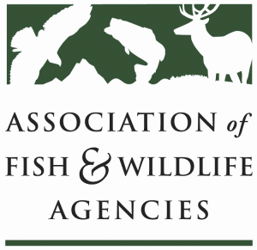

Invasive species Committee
Chair: Bill Hyatt (CT)
Vice-Chair: Kim Bogenschutz (IA)

Monday, September 11, 2017
NEW TIME: 8:00 am to noon (MT)

AFWA Annual Meeting
Room: Wasatch B, Snowbird Resort
Sandy, UT

Agenda
8:00 am Call to Order, Welcome and Introductions, Review Agenda
Bill Hyatt, CT DEEP

8:15 AFWA updates
Committee Work Plan review
Bill Hyatt, CT DEEP/Kim Bogenschutz, IA DNR
Invasive Species Legal Compilation
Evan Keimach, Michigan State University/Priya Nanjappa, AFWA

8:40 NISC/ISAC Updates and Strengthening Fed-State Coordination report
TBD, NISC/Bill Hyatt, CT DEEP

9:00 Western Invasive Weed Action Plan and Sagebrush/Greater Sage Grouse Conservation
Meghan Brown, Nevada Department of Agriculture

9:40 Partner updates
USFWS (David Hoskins/Dave Miko)
ANS Task Force (Kim Bogenschutz, IA DNR)
Wildlife Forever (Doug Grann/Pat Conzemius)

10:00 BREAK

10:30 Discussion: MOU among PIJAC-FWS-AFWA, proposed updates
Bill Hyatt, CT DEEP/Kim Bogenschutz IA DNR

10:50 Updates: Building Consensus in the West
American Boat and Yacht Council (Priya Nanjappa, AFWA)
National Sea Grant Law Center activities (Stephanie Otts, NSGLC)

11:00 Discussion: Lacey Act Court Ruling Impacts to States, Desired Actions
Priya Nanjappa, AFWA/Bill Hyatt, CT DEEP

Agenda (cont’d)

11:20 Update: AFWA Feral Cat Working Group
Colin Gillin, ODFW

11:30 Relevant Legislative Updates
Devin DeMario, AFWA

11:40 Round Robin (all)

11:55 Summary of Action Items and Wrap-Up

12:00 Adjourn

