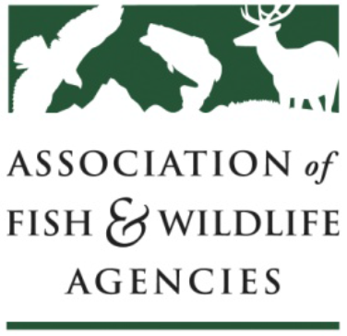
AFWA Committee Work Plan
Worksheet

Guidelines: Each AFWA Committee, Subcommittee and Workgroup is required to review their charge and develop a work plan at the AFWA Annual Meeting and submit to John Lord, Operations Director, jlord@fishwildlife.org by October 1. The purpose of the work plan is to improve communication and effectiveness of committee work and enable committee chairs and the Executive Committee to evaluate their status annually.

Committee Work Plan
Date: 6 September 2017
Committee Name: Amphibian & Reptile Conservation Committee

Chair: Cathy Sparks | Vice Chair: Thomas Eason | Staff: Priya Nanjappa
Committee Charge:
The Amphibian and Reptile Conservation Committee identifies effective means and guidance for member states, provinces, territories, tribes, and federal agencies to address and advance herpetofaunal conservation priorities, including through improved policies, funding avenues, and via interagency and external partner collaboration. The committee seeks opportunities for increased interactions with other AFWA committees, and advises or assists on cross-cutting issues involving amphibians, reptiles, or their habitats, as needed or requested. In addition, the committee is a forum for discussion, information sharing and dissemination of emerging threats, and for development of new and improved conservation tools and solutions.

Changes to the Charge:

List Major Activities and Objectives Accomplished During the Last Year:
1. Became approved as a full AFWA Committee
2. Secured nearly ~$500K from a private funder to address Bsal priority research on native US species, among other wildlife health matters.
3. Kept Committee members and state fish & wildlife agencies updated on developments related to amphibian and reptile diseases.
4. Shared research and relevant developments in relation to state and federal laws and regulations.
5. Represented the Committee in various amphibian and reptile conservation communities, including: the Bsal Task Force, the PARC Joint National Steering Committee and the PARC Disease Task Team, and the AFWA Law Enforcement Committee Intelligence Summit.

List Activities and Objectives that Will be Accomplished in the Coming Year:
1. Continue implementing the grant supporting Bsal research and strategic wildlife health efforts, and disseminating new research findings as well as identifying new research priorities.
2. Explore opportunities for state-level pathogen prevention via collaboration with AFWA Fish & Wildlife Health Committee on a survey regarding existing state laws, and efficacy thereof, as well as fisheries pathogen prevention models (e.g., AFS “Blue Book” and Aquatic Animal Health Plan).
3. Continue tracking state and federal regulatory changes and provide information or assistance to states as needed in applying the North American Model of Wildlife Conservation to amphibian and reptile management.
4. Assist PARC in the finalization of the Timber Rattlesnake Conservation Action Plan, and development of additional species conservation action plans (e.g., for Western Pond Turtle or other species).
5. Plan a joint session with the AFWA LE Committee in the coming year to discuss amphibian and reptile trafficking trends, and needs for assistance.

Comments:

Subcommittee Work Plan
Date:
Subcommittee Name:

Chair: | Vice Chair: |  | Staff:
Subcommittee Charge:

Changes to the Charge:

List Major Activities and Objectives Accomplished During the Last Year:
1.
2.
3.
4.
5.

List Activities and Objectives that Will be Accomplished in the Coming Year:
1.
2.
3.
4.
5.

Describe any Changes you Anticipate to the Subcommittee:

List Subcommittee Members:

Comments:

Workgroup Work Plan
Date:
Workgroup Name:

Chair: | Vice Chair: |  | Staff:
Workgroup Charge:

Changes to the Charge:

List Major Activities and Objectives Accomplished During the Last Year:
1.
2.
3.
4.
5.

List Activities and Objectives that will be Accomplished in the Coming Year:
1.
2.
3.
4.
5.

Describe any Changes you Anticipate to the Work Group:

List Workgroup Members:

Date Workgroup Formed: |  | Expected Termination Date:
Comments

