Private Lands Staffing - On-boarding and Training
Survey Results
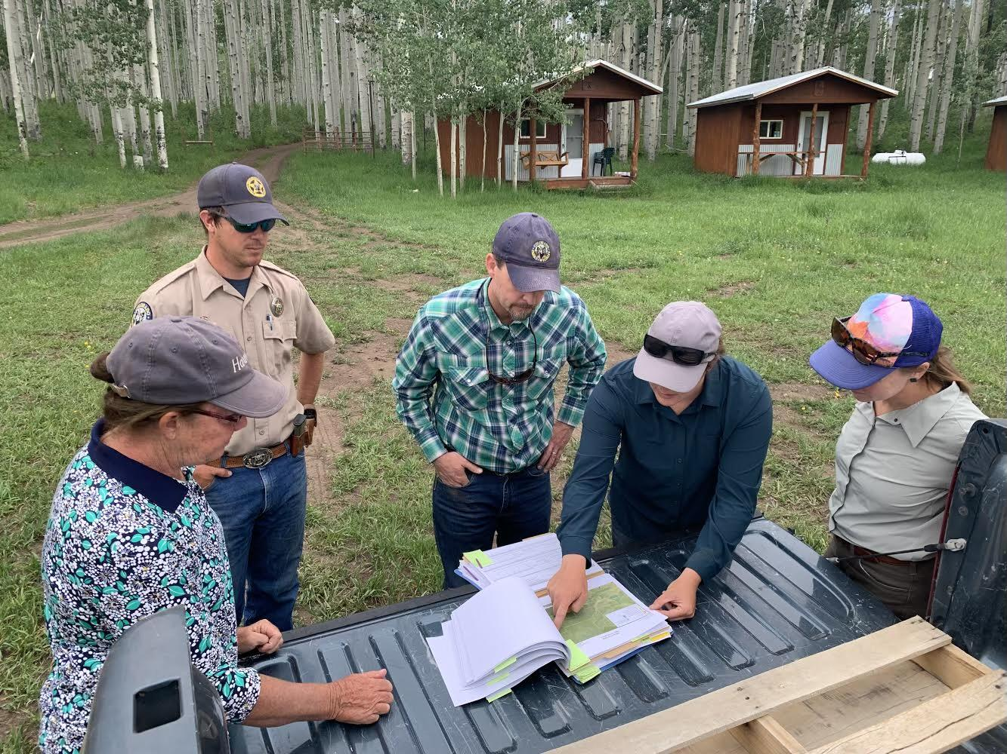

Survey Design & Delivery: Surveys were distributed to 48 States in June and July 2023 using Qualtrics. 33 States Responded. 15 total questions.

Summary Findings:
- 33 States responded.
- 30 States indicate having staff (partner or agency staff) committed to private lands.
- 25 States indicated that there is full-time agency staff dedicated to private lands conservation delivery.
- Respondents indicated need/strong need for more training/curricula aimed at private lands conservation in University programs focused on natural resource and wildlife management.
- The majority of respondents indicated that they use an “informal” training process for onboarding new private land staff.
- Respondents indicated that they feel their training efforts are moderately effective.
- Individualized/mentored was the training method most utilized and a training duration of 2-5 days was the most frequent.
- 76% of respondents indicated that there is no training regarding private lands conservation provided to other State agency staff (non-private land focused).
- The top two preferred methods for delivering training to State agency private lands staff were: State Specific Training Delivered by Your Agency & State Specific Training Offered by Outside Vendor.
- The top indicated limiting factor for improving/implementing training related to private lands conservation delivery was “Time” with “Lack of Resources” a distant second.
Results

Question #1: Job title of those completing the survey.

Program Lead (Landowner Relations, Private Lands, Farm Bill): 18
Director or Chief: 5
Habitat Focused: 5
Biologist: 3
Small Game/Upland Game: 2

Question #2: Does your State Wildlife Agency employ staff designated towards private land conservation efforts?

Yes - 30
No - 3

Question #3: Please select all that pertain to your State's Private Land Staffing:

Full-time, staff designated to delivering private lands programs: 25
Partner Positions: 24
Portion of full-time staff dedicated to private lands delivery: 15
Other: 4 (projects brought to state agency from partners leading to collaborations)

Question #4: Recognizing the role of academic programs in training conservation professionals, how would you rank the aptitude of recent graduates in the following areas of expertise needed for private lands conservation delivery?
1-10 Scale with 0 = Non-existent and 10 = Mastery

Wildlife Ecology: 5.8
Wildlife Habitat Needs: 5.7
Applied Habitat Practices: 3.7
Interpersonal skills: 3.4
Equipment Operation for Habitat Improvement: 2.3
USDA/Farm Bill Programs: 2.0
Agricultural Economics: 2.0
Agricultural Practices/Production Models: 1.9

Question #5: What type of Private Lands conservation delivery training program does your Agency/Program deliver to support the onboarding of new Private Lands staff (Agency and/or Partner Positions)?

Informal Training Program: 22
Formal Training Program: 6
No Training Program: 5

Question #6: Please select all topics you currently include in your formal training program:

Habitat Practices: 17
USDA/Farm Bill Programs: 16
Working with Landowners/How to Talk to Landowners: 13
Specific Programs Offered by Your Agency: 13
Wildlife Biology/Ecology Specific to Your Area: 12
Agricultural Practices: 11
Public Access: 7
Legal Items (Safe Harbor, Leases, etc..): 6
Local Issues, Culture, History: 4
Equipment Operation: 4
Conservation Easements: 3
Agricultural Economics: 1
Energy Development: 1

Question #7: Please rate how effective you feel your training programs are for the above:
0-10 Scale with 0 = Not at All Effective, 10=Extremely Effective

Mean: 4.7

Question #8: Please choose the most accurate representation of the amount of time committed to the above training efforts:

1 day or less: 6
2-5 days: 11
1-2 weeks: 8
More than 2 weeks: 5

Question #9: Please select the structure or structures you use to deliver your training(s):

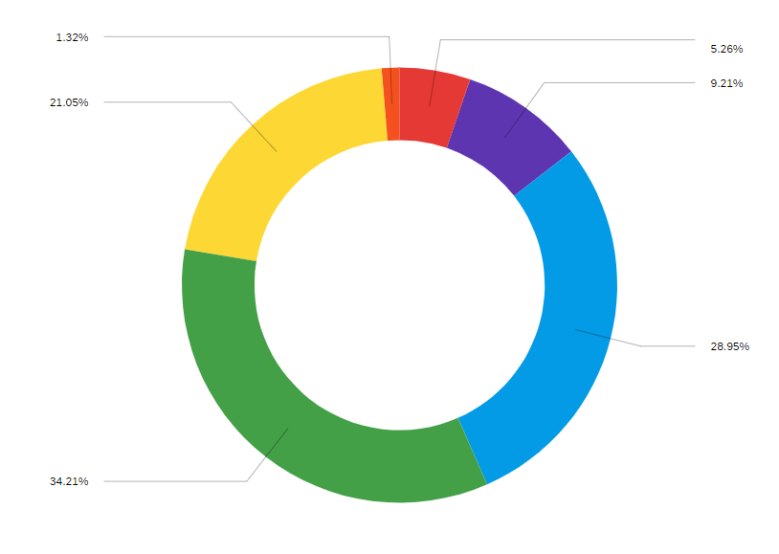
Individualized (mentored/one-on-one): 26
Field-based: 22
Group-based: 16
Classroom: 7
Web-based: 4
Other: 1 (“no formal training”)

Question #10: Does your Agency incorporate training, specific to private lands, into training other (non-exclusive to private lands) agency staff?

Yes: 8
No: 25

Question #11: If yes, briefly describe the training, specific to private lands, of other (non-exclusive to private lands) agency staff:

“We take other staff on field trips/tours.”
“1 Hour presentation to training class of new game wardens”
“45 minute training the cadet class”
“New staff exposed to basics of private lands programs”
“Opportunistic training towards habitat basics that are relevant to both private and public lands.”

Question #12: Please select any of the following your agency has engaged with to provide initial or ongoing training to your private lands staff (including both Agency and/or Partner positions)

Partnerscapes: 8
National Bobwhite & Grasslands Initiative Trainings: 8
Academic Program/Institute Trainings: 6
North American Bird Conservation Initiative Trainings: 4
Others: 7
- Longleaf Academies, Prescribed Burn Training, NRCS trainings,
- We have initiated field days around grassland restoration and open savannah workshops that are multiagency and open to landowner/practitioners to facilitate conversation and learning of on the ground practices not just ideas of what should be done. 8 around the state this year with over 350 attendees.
- Local trainings; eg, range schools, Rx Fire workshops etc.
- USDA NRCS
- Iowa Land Stewardship Leadership Academy (Iowa State Extension) & USDA Trainings
- USDA, SD Grassland Coalition, PF,DU

Question #13: Please rank the following from 1(most desired) to 6 (least desired) for meeting your private lands training needs:
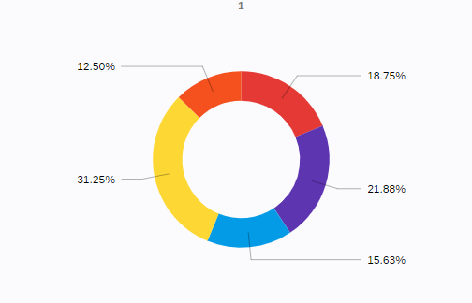
State Specific Training Delivered by Your Agency - 31%, Choice 1
State Specific Training Offered by Outside Vendor - 21%, Choice 1
Regional/Multi-state Symposia - 18%, Choice 1
Web-based Learning Modules - 15%, Choice 1
Increased course/curriculum Content in Academic Degree Programs - 12%, Choice 1
Paper Based Curriculum - 0%, Choice 1

Question #14: Please rank those obstacles you believe limit your agency in onboarding and supporting staff training related to conservation delivery on private lands:
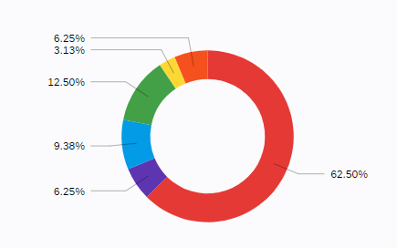
Time: 62%, Choice 1
Resources (other than money/time): 12%, Choice 1
Expertise: 9%, Choice 1
Money: 6%, Choice 1
Other: 6%, Choice 1
Previous Training and Experience Limitations with Prospective Candidates/New-Hires: 3%, Choice 1

Question #15: Please describe your unmet needs and/or ideas for training private lands staff to assist in meeting your Agency goals and mission.

Helping new staff understand the process based practice of habitat management and how to build trust with private landowners is paramount. Many come in with great motivation and hit the ground running, but the reality of private land work is that people get sick, run out of money, don't prioritize the work that is contracted, etc. Project management skills are very important for private lands staff and is definitely not something most people are trained in during current course work. It is imperative when managing multiple projects/landowners conducting different practices that need to occur on certain timelines to treat certain plant physiology for best control (herbicide timing/efficacy, mechanical manipulation, proper planting windows, etc). This is the biggest learning curve that I see for new biologists and what discourages veteran biologists from engaging in as many projects.
Most of our training is informal mentoring and training by the person who previously held the position. getting an agency to invest in dedicated resources for training can be difficult
Our agency goals and mission relate to ensuring that habitat management is not only conducted on wildlife management areas but also on private lands. This involves working with partners (private landowners, land trusts, conservation organizations, tribes, and municipalities) to plan, fund, and implement management on their lands. Meeting those goals requires a different skill set than does planning and conducting management on state lands. As with management on state lands, staff need training in habitats that need active management, associated species, and techniques used to manage habitat. Beyond the training that is necessary for staff to accomplish management on state lands, those that work with partners on private lands also need training on how to develop outreach messaging and effective techniques for interacting with landowners to successfully encourage and facilitate their involvement in conservation activities. They need an awareness of the various types of landowners (farmers, forest, recreational etc.) and the variety of landowner motivations for conducting active habitat management. Staff working with private landowners also need to have a good understanding of all technical and financial resources available to private landowners. Unmet needs or ideas for training private lands staff to assist in meeting our agency goals and mission include a lack of formal training or workshops designed to provide staff with the necessary skills and techniques required to successfully engage private landowners in habitat conservation.
We are in need of a formalized plan to support on-boarding of our partner positions. As well, our biggest limiting factor is overall lack of emphasis on private lands conservation opportunities by our State Agency. This is reflected in our designated staff towards private lands (1) and lack of training for additional agency staff that does interact with private landowners and agriculturalist (nearly non-existent).
We need tools to help make interactions with landowners more efficient. Developing these tools has always proven to be challenge as private landowner success is based on relationship building. Sharing what other states us for "first cut" tools would be beneficial as we figure out how to spend our staff resources with the most interested landowners and effective projects.
Currently my agency does not provide any training specific to private lands. I have had to seek out all of my training alone and learn on my own. Agency training on USDA programs from USDA staff would be helpful. Training from other state agencies on their programs would be helpful as well. Training on communication tactics and strategies (public outreach and communication, social science, human dimensions) would be beneficial for private lands staff (I am the sole staff person) and staff that encounter members of the public (regional biologists, species specialists, etc). Additional training at the undergraduate level would be extremely beneficial. My program briefly covered USDA/Farm bill programs during one lecture, and never again. Field visits for students to producers using state or federal programs could help lay a better foundation.
We really provide no formal training for new employees or existing. Most of them learn on the job, from conversations with other biologists, supervisors and program heads. This of course, especially with turnover, makes any consistency extremely challenging and is very depended on the individuals. It would be great to have a multi- tiered approach. With the universities training on actual habitat management practices, basics of agricultural operations, ag economics etc, have a multi-state training for USDA/farm bill, FWS programs, and national options and then program options within the state. It would be very nice to have some sort of web-based fact sheet or training with basic information and contacts. Because currently, would say we do a poor job of setting up our biologists for success in private lands programs at this juncture.
In the deep south we could use more training specific to non-conventional forest management, agricultural production systems, prescribed fire, forestry BMPs and infrastructure (e.g., roads, structures, etc.), and forestry herbicides. I'm sure there are other topics as well.
We lack expertise in agronomic crop practices to support wildlife such as conservation cover. We have limited expertise in grazing systems and practices that are beneficial to wildlife.
What I have experienced is that many private land biologists are focused so heavily on their individual projects or agreements with landowners that they fail to see how they fit into the big picture. And vice-versa, Managers are busy planning for big picture outcomes and failing to communicate with field staff how they are part of that big picture. Some of this comes down to the individuals, some are motivated and want to be involved in big picture, others simply want to do their work and move on to the next project. Finding the right person to do private lands work is important because I want an individual who will do great work with landowners, but I also want someone to think big. We seem to get one or the other with our recent applicants. We've even go so far as thinking we need someone who has the right demeanor and personality to talk to landowners, even if they don't have a lot of habitat or program experience because we feel we can train them to learn those things, but we can't do much about their personality.
We currently lack the following items and will be working to build these items as we train 8 new wildlife management consultants (DNR biologists focused primarily on private lands). -Training framework - Standardized training sessions (held seasonally for field exercises) - Mentoring program A regionally focused training opportunity (similar to the NABCI Private Lands Forum - 2022) would be very helpful to fulfill training needs (especially at the beginner to intermediate levels).
I'm being asked to develop a training curriculum for onboarding staff within 18-24 months so expectations could be established on what and how they would deliver habitat on private lands. I'm also being asked for the same with existing staff (11). In my opinion this would be a mix of onboarding training and continuing education at a more regional level with multiple states.
The most important piece of training PL Staff is to have them understand habitat evaluation and to understand how to recommend and develop improvement plans. This happens best one-on-one with a mentor in the field. Second is state specific farm bill program guidance. Mainly, creation of a guide that points people in the right direction to find their answers. There is too much info to learn at one time, but a guide so that they understand where to find answers is helpful forever.
There is little formal coordination surrounding our private lands staff and training. If there is training, it is usually us training consulting foresters or newly hired NRCS staff. We do not have a formal onboarding program. It would be beneficial to have one as I am in my 7th year of providing private lands TA and I'm still not sure I'm doing it right.
Understanding agricultural logistics and practices. Possible topics could include: 1) How to interpret markets 2) Understanding cattle/ranch terminology (e.g. fat cattle, backgrounding, AI, weaning, positives and challenges with calving 3) A year in review for a farmer and rancher (decision making, farm practices, terminology, equipment). Having a broader understanding of our constituents can drive conversations with landowners and gain respect and trust quicker.
My agency doesn't really have a formal training program. We have a web based training library for some training and our private lands staff mentor new staff to get them up to speed on the field components after they are hired. I think our agency could benefit greatly from a training program for staff in and out of the private lands division.

Outcomes and Actions

- Engagement with universities, trade schools and others in developing a more robust curriculum to meet the needs of State agencies in securing qualified candidates to deliver private lands conservation.
- Clearly identifying the core elements of training needed to support private lands staff in delivering conservation outcomes.
- Development of standardized, intentional training for new private lands conservation staff informed by each State’s unique needs.
- Sharing and development of resources (training guides, curriculum, videos, examples & case-studies) across AFWA members to support private land training.
- Exploring the possibilities for outside vendors and partners delivering State or regional training focused on private lands conservation delivery.
- Continued need to support State Agency leadership in valuing private lands conservation through training, positions and strategic programming.

