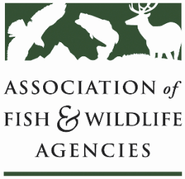

**Conservation Reserve Program Working Group**

**Chair: Todd Bogenschutz (IA)**

**Vice-Chair: Sal Palazzolo (ID)**

**Date: Tuesday, September 23rd, 2025**

**Time: 1:15 – 3:15 pm**

**115th AFWA Annual Meeting**

**Tucson, Arizona**

**Agenda**

1:15 pm Review Agenda/Introductions

1:25 pm Primary Nesting Season Dates – Kristen Ellis, USGS Northern Prairie WRC

1:55 pm CRP Outlook

* FSA/NRCS Update – recent sign-up results, cap, etc. (tentative)
* CRP Improvement Act Language—Andrew Schmidt, Pheasants Forever
* Grassland CRP Marker Bill—Steve Riley, American Bird Conservancy
* State Round Table – Farmbill 2.0
* AFWA CRP Platform change
* CRP – likely 2024 House language, AFWA must haves for CRP
* Give the change to soil productivity factors this signup should they be in statute?
* Other issues
  + Impact of reconciliation bill loophole on future of CRP land rents
  + SE Trees, need variance to burn for management during primary nesting seasons.
  + Other topics from states

3:00 pm NGO/Partner Updates

3:15 pm Adjourn