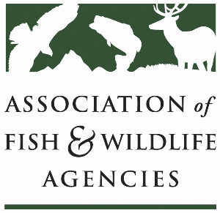

**AGRICULTURE CONSERVATION COMMITTEE**

**Chair: Kevin Robling (South Dakota)**

**Vice-Chair: Tim McCoy (Nebraska)**

**Wednesday, September 24th, 2025**

**8:00 – 12:00 pm**

115th AFWA Annual Meeting

Tucson, Arizona

**Agenda**

8:00 am Call to order, Review agenda

8:05 am Introductions

8:15 am Approval of Minutes for the 2024 AFWA Conference

8:20 am New Business

(Tentative) NRCS/FSA Updates

2025 Farm Bill Priorities

* Vote on updated platform

Grassland conservation ideas

* How can this committee advance national grasslands conservation efforts?
* Policy/management/market proposals

Working Group Reports

* + - CRP
    - Easements
    - EQIP/CSP
    - Forestry
    - RCPP
    - Public Access
    - Private Lands

11:45 am Final Remarks, Identification of Action Items

12:00 pm Adjourn