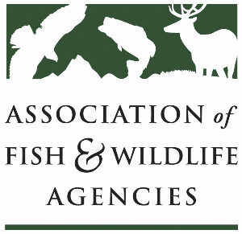

**Subcommittee on water**

Chair: Julie Carter (AZ)

Vice-Chair: Bob Caccese (PA)

Tuesday, March 11

1:15pm – 3:15pm

90th North American Wildlife and Natural Resources Conference

Louisville, Kentucky

**Agenda**

1:15 pm Call to Order/Review Agenda/Approval of Minutes – *Julie Carter, AZ*

1:20 pm Introductions – *All*

1:25 pm Virtual Pre-Meeting Recap – *Julie Carter (AZ)*

1:40 pm Government Affairs Update – *Ali Schwaab (AFWA)*

* Federal Budget, WRDA, Permitting Reform and Executive Orders

1:55 pm National Water Availability Assessment – *Kevin Pope (USGS)*

2:05 pm Instream Flow Council Update – *Christopher Estes, AFWA Life Member*

* National Center for Ecologically Sustainable Water Conservation and Management

2:20 pm Update on Golden Mussel Detection and Response *– TBD*

2:30 pm Roundtable on State Water Quantity and Quality Issues *– All*

2:55 pm Federal Partner Updates

* USGS – *Kevin Pope (USGS)*
* BLM
* FWS
* Others?

3:10 pm Wrap-up Discussion and Adjourn – *Julie Carter (AZ)*

* Action items for FWRPC