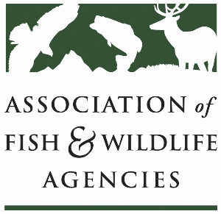

**Forestry Working Group**

**Chair: Brad Alexander, Georgia**

**Vice-Chair: John Taucher, Pennsylvania**

**Monday, September 23rd, 2024**

**3:00 pm – 5:00 pm**

114th Association of Fish & Wildlife Agencies Annual Meeting

Madison, Wisconsin

**Agenda**

3:00 pm Call to Order/Introductions/Review Agenda

3:10 pm FCEP: Implementation and how we can affect draft language

3:40 pm Forestry for wildlife habitat through Farm Bill programs:

* Guest speaker: NRCS National Forester

4:20 pm Roundtable: Updates from states and partners to provide information on:

* Forest Management Incentive for Conservation Reserve Program
* Capacity for Forestry Practices (contractors, habitat crews and other initiatives)
* Forest Legacy Programs
* PM 2.5 mitigation

5:00 pm Adjourn