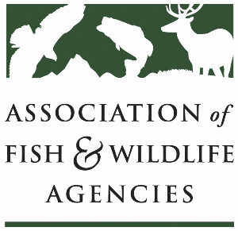

**AGRICULTURE CONSERVATION COMMITTEE**

**Chair: Kevin Robling (South Dakota)**

**Vice-Chair: Tim McCoy (Nebraska)**

**Wednesday, September 25th, 2024**

**8:00 am—12:00 pm**

114th Association of Fish & Wildlife Agencies Annual Meeting

Madison, Wisconsin

**Agenda**

8:00 am Call to order, Review agenda

8:05 am Introductions

8:10 am Approval of Minutes for the 2024 North American Meeting

8:15 am Farm Bill Updates & Priorities

9:00 am NRCS Updates

9:30 am Working Group Reports

* + - CRP
    - Easements
    - EQIP/CSP
    - Forestry
    - RCPP
    - Public Access
    - Private Lands

10:30 am Government Affairs Update

11:00 am Roundtable/Open-Mic Discussion (*pressing issues/questions among committee members)*

12:00 pm Adjourn