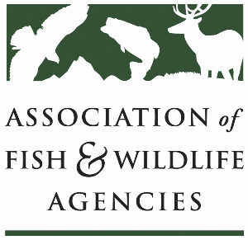

**Private LAnds Working Group**

**Chair: Will Newman, Texas**

**Vice-Chair: Ray Aberle, Colorado**

**Monday, September 23rd, 2024**

**10:00 am – 12:00 pm**

114th Association of Fish & Wildlife Agencies Annual Meeting

Madison, Wisconsin

**Agenda**

10:00 am Call to Order/Introductions/Review Agenda

10:05 am Quick Updates

* Private Lands Delivery “Census” Update/Product
* NABCI Private Lands Guide
* Private Lands Stewardship Academy Recap
* Other updates and discussion for Capacity Development Effort

10:35 am New Business

* Sand County Foundation Presentation
* Private Landowner Recognition Programs
* Regional Associations and Other Private Lands Working Groups
* Previously Identified WG Needs

11:40 am Record Action Items, Form Task Groups, Set Product Goals

12:00 pm Adjourn