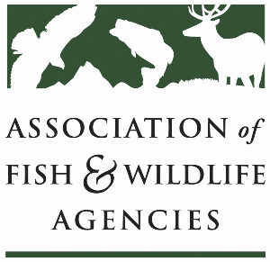

**Private LAnds Working Group**

**Chair: Will Newman (TX)**

**Vice-Chair: Ray Aberle (CO)**

**Monday, September 22nd, 2025**

**10:15 am – 12:15 pm**

**115th AFWA Annual Meeting**

**Tucson, Arizona**

**Agenda**

10:15 am Call to Order/Review Agenda

10:20 am Introductions

10:25 am (Tentative) EPA Funding Opportunities for Private Lands Conservation

* Jeff Lerner, Office of Wetlands, Oceans, and Watersheds

10:55 am New Business

* Development of SEAFWA Private Lands WG: Brad Alexnader (GA)

11:15 am Old Business

* NABCI Private Lands Guide: Will Newman (TX)
* Other updates and discussion for Capacity Development Effort
* Review of our previously identified “next steps” for the working group and private lands conservation efforts

12:10 pm Record Action Items, Form Task Groups, Set Product Goals

12:15 pm Adjourn