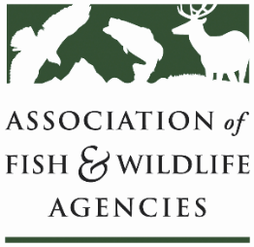

**Conservation Reserve Program Working Group**

**Chair: Todd Bogenschutz (IA)**

**Vice-Chair: Sal Palazzolo (ID)**

**Date: Wednesday, September 24th, 2024**

**Time: 1:00 – 3:00 pm**

114th Association of Fish & Wildlife Agencies Conference

Madison, Wisconsin

**Agenda**

1:00 pm Call to Order/Review Agenda

1:10 pm Landowner Conservation Persistence after Payments End: Insights from CRP Dr. Ashley Dayer

1:40 pm Farm Bill Updates

* Update from FSA on 2024 CRP enrollments (general, CCRP, and grassland)
* Status of 2024FB
* Updates on the WY/Grassland issue
* Discussion on Grasslands CRP Cap
* Burn plan requirements for CRP
* Action items from previous meetings:
  + Look into how we can get AgLearn public access for CRP trainings
  + Letter to support CRP in FB extension

2:30 pm State roundtable

2:50 pm Partner Updates

* Pheasant Forever update on CRP MAE funding, Scott Taylor

3:00 pm Adjourn