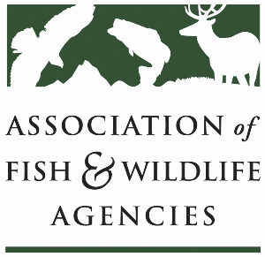

**Farm bill Easements WORKING GROUP**

**Chair: David Breithaupt**

**Vice Chair: Vacant**

**Tuesday, September 24th, 2024**

**8:00 am – 10:00 Am**

114th Association of Fish & Wildlife Agencies Annual Meeting

Madison, Wisconsin

**Agenda**

8:00 am Call to Order/Review Agenda/Introductions

8:05 am NRCS Updates

* Tri-State Partnership
* RCPP Easements

8:45 am FCEP: Implementation and how we can affect draft language

9:00 am State Roundtable

9:50 am Working Group Action Items

10:00 pm Adjourn