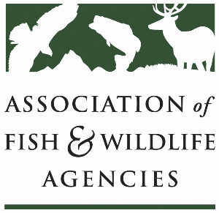

**Rcpp Working Group**

**Chair: Lisa Potter (MO)**

**Co-Chair: Angela Reseland (WA)**

**Monday, September 22nd, 2025**

**1:15 pm – 3:15 pm**

**115th AFWA Annual Meeting**

**Tucson, Arizona**

1:15 pm Call to Order/Review Agenda

1:20 pm Introductions

1:25 pm Policy Update: RCPP in the Reconciliation Bill

1:40 pm (Tentative) Federal Update: Timing on future grant applications?

2:10 pm Round table: RCPP Grant Recission Impacts/State Roundtable

3:00 pm Partner Updates

3:15 pm Adjourn