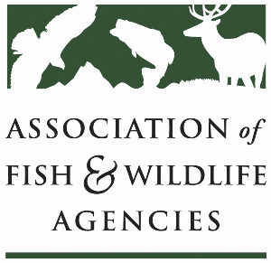

**AGRICULTURE CONSERVATION COMMITTEE**

**Chair: Kevin Robling (South Dakota)**

**Vice-Chair: Tim McCoy (Nebraska)**

**Wednesday, September 24th, 2025**

**8:00 – 12:00 pm**

115th AFWA Annual Meeting

Tucson, Arizona

**Agenda**

8:00 am Call to order, Review agenda

8:05 am Introductions

8:15 am Approval of Minutes for the 2024 AFWA Conference

8:20 am New Business

(Tentative) NRCS/FSA Updates

2025 Farm Bill Priorities

* Vote on updated platform

Grassland conservation ideas

* Examples from SD
  + Every Acre Counts ([Video](https://www.youtube.com/watch?v=mtnrt42dLPE)) ([Website](https://extension.sdstate.edu/agriculture/every-acre-counts))
  + Where Good Things Grow ([Videos](https://www.wheregoodthingsgrow.org/about-us/)) ([Website](https://www.wheregoodthingsgrow.org/about-us/))
* How can this committee advance national grasslands conservation efforts?
* Policy/management/market proposals

Working Group Reports

* + - CRP
    - Easements
    - EQIP/CSP
    - Forestry
    - RCPP
    - Public Access
    - Private Lands

11:45 am Final Remarks, Identification of Action Items

12:00 pm Adjourn