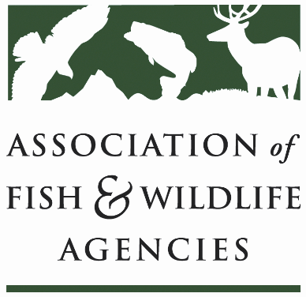
Rcpp Working Group
Chair: Lisa Potter, Missouri
Co-Chair: Angela Reseland, Washington

Monday, September 23rd, 2024
1:00 pm – 3:00 pm

114th AFWA Annual Meeting
Madison, Wisconsin

Agenda

1:00 pm Call to Order/Review Agenda

1:10 pm Landscape Conservation Initiative Gordon Meyers

1:15 NRCS Updates

1:40 Summary of RCPP feedback discussion with FPAC Leadership

Request for input:

- Advance Payments: Are there examples of how partners are finding solutions to no advance payment options?
- Are there specific examples of partners not able to submit multi-state proposals due to some states NOT offering an Alternate Funding Arrangement (AFA) proposal option?
- Identify models of state partnerships that are working well and determine how we can replicate them in other states.

2:10 Supplemental Agreements
- Level of detail requested
- Technical Assistance: Implementation vs. Enhancement
- Administrative costs – supplies
- NRCS TA percentages for AFA projects
- Compliance Requirements – AFAs

2:30 RCPP Summit
- What is the need
- Virtual vs. In person
- NRCS involvement
- How to increase tribal partner engagement

2:40 State Roundtable

2:55 Final remarks
3:00 Adjourn

