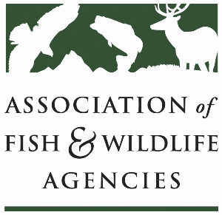

**Public access WORKING GROUP**

**Chair: Sal Palazzolo, Idaho**

**Vice-Chair: Mark Norton, South Dakota**

**Tuesday, September 24th, 2024**

**3:00 pm – 5:00 pm**

114th Association of Fish & Wildlife Agencies Annual Meeting

Madison, Wisconsin

**Agenda**

3:00 pm Call to Order/Review Agenda

3:05 pm Farm Bill Update Shane Behler

3:10 NRCS Update

3:25 pm State Presentation on Public Access Programs

* Jenny Prenosil, Nebraska
* Travis Schultz, Oregon
* Brad Alexander, Georgia

4:10 pm Discussion on FY-2024 Funding Applications and Appropriations

4:30 pm State Roundtable (*One representative per state agency*

*highlights a couple of legislative and policy initiatives or issues)*

5:00 pm Adjourn