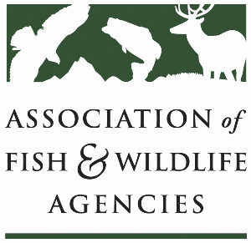

**eqip & CSP Working Group**

**Co-Chair: Cody Rhoden, Kentucky**

**Co-Chair: Derek Wiley, Texas**

**Tuesday, September 24th, 2024**

**10:00 am – 12:00 pm**

114th Association of Fish & Wildlife Agencies Annual Meeting

Madison, Wisconsin

**Agenda**

10:00 am Call to Order/Review Agenda/Introductions

10:05 am Approval of Minutes from 2024 North American Meeting

10:10 am NRCS Updates

* Working Lands For Wildlife
* EQIP in CRP in Western States
* CSP Update—by the numbers, farmland vs. rangeland

10:30 am Inflation Reduction Act

* Discussion on inclusion of wildlife-friendly practices, identify action items.

11:30 am State Roundtable

11:50 am Working Group Action Items

12:00 pm Adjourn