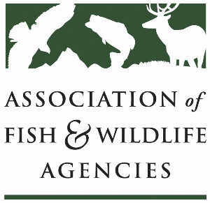

**Farm bill Easements WORKING GROUP**

**Chair: David Breithaupt (LA)**

**Vice Chair: Jenny Prenosil (NE)**

**Tuesday, September 23rd, 2025**

**8:00 – 10:00 am**

**115th AFWA ANNUAL MEETING**

**TUCSON, ARIZONA**

8:00 am Call to Order/Review Agenda

8:05 am Introductions

8:10 am Easement Funding in Reconciliation Bill

8:20 am Federal partner update

9:00 am Tri-state Partnership Presentation

* David Breithaupt, Louisianna Dept. of Wildlife & Fisheries

9:30 am NGO/Partner Updates

10:00 am Adjourn