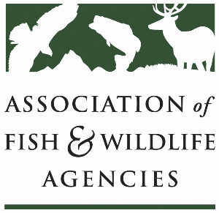

**Forestry Working Group**

**Chair: Brad Alexander (GA)**

**Vice-Chair: John Taucher (PA)**

**Monday, September 22nd, 2025**

**3:30 pm – 5:30 pm**

**115th AFWA Annual Meeting**

**Tucson, Arizona**

**Agenda**

3:30 pm Call to Order/Review Agenda

3:35 pm Introductions

3:40 pm Forestry Policy Update

* Reconciliation Bill Impacts on the Forestry Title
* Forest Conservation Easement Program Act
* Fix Out Forests Act
* Cottonwood Lawsuit “Fix”

4:10 pm NBGI Technical Committee Update & State Policy Impacts

* Brad Alexander, GA

4:30 pm Public Awareness of Prescribed Burning

4:45 pm State/Partner Updates

5:15 pm Future of the Work Group and AFWA Engagement on Forestry Topics

5:30 pm Adjourn