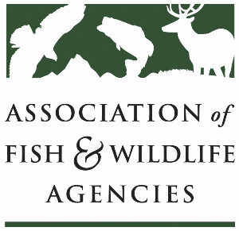

**Public access WORKING GROUP**

**Chair: Sal Palazzolo (ID)**

**Vice-Chair: Mark Norton (SD)**

**Tuesday, September 23rd, 2025**

**3:30 pm – 5:30 pm**

**115th AFWA Annual Meeting**

**Tucson, Arizona**

3:30 pm Call to Order/Review Agenda

3:35 pm Introductions

3:40 pm Policy Update: VPA in the Reconciliation Bill

4:00 pm State Presentation on Public Access Programs

* Dan Sturla, Arizona
* Tim Schaeffer, Pennsylvania Fish & Boat Commission

4:30 pm Ideas to bridge the gap between VPA-HIP grants

5:00pm State Roundtable/Partner Updates (*One representative per state agency highlights a couple of legislative*

5:30 pm Adjourn