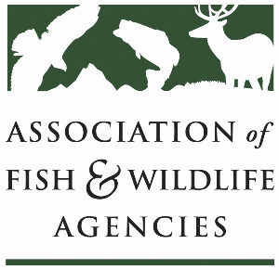

**eqip & CSP Working Group**

**Co-Chair: Derek Wiley (TX)**

**Co-Chair: Cody Rhoden (KY)**

**Tuesday, September 23rd, 2025**

**10:15 am – 12:15 pm**

**115th AFWA Annual Meeting**

**Tucson, Arizona**

**Agenda**

10:15 am Call to Order/Review Agenda

10:20 am Introductions

10:25 am Reconciliation Bill Impact on EQIP & CSP Funding

Time TBD (Tentative) Federal Partner Update

11:45 am Partner Updates

12:15 pm Adjourn